UNIVERSITY OF PETROLEUM AND ENERGY STUDIES


Student Name: Deepanshi Shukla
Sap ID: - 590021964
Batch: B10
Course: B. Tech (CSE)
SUBJECT: python Programming lab
Experiment: 8
Submitted to:
Kamakshi Rautela

Experiment 8: GUI and Backend Connectivity
1. Create a simple Tkinter window with a title and fixed size.
CODE: -
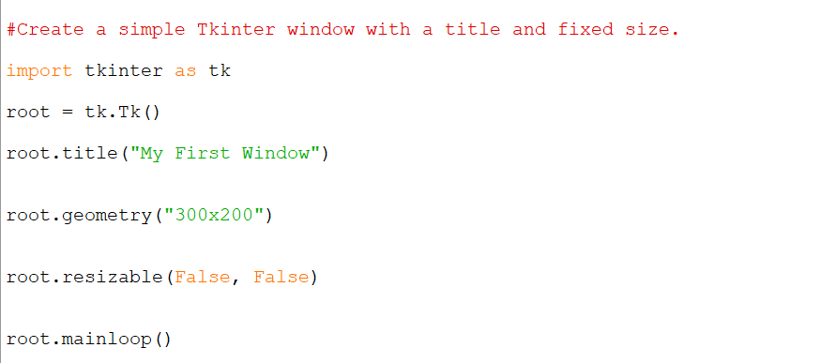
RESULT: -
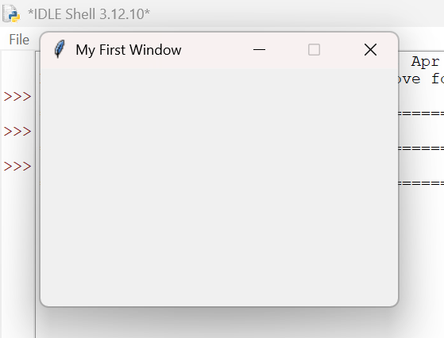
2. Design a GUI based basic calculator for performing basic arithmetic operations.

CODE: -
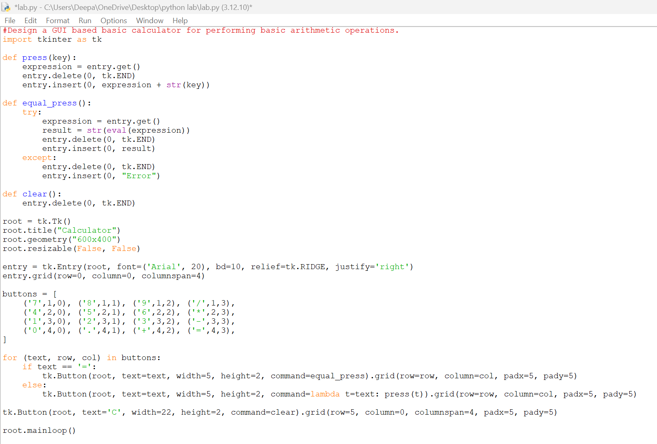
RESULT: -
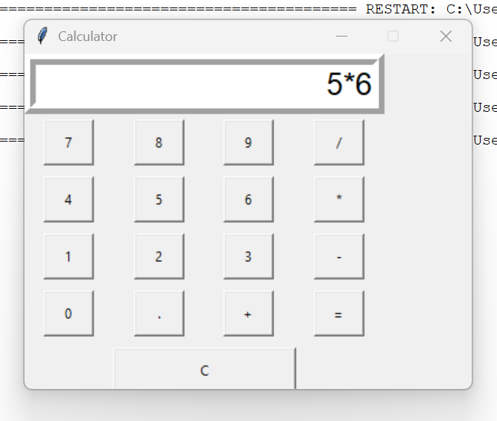
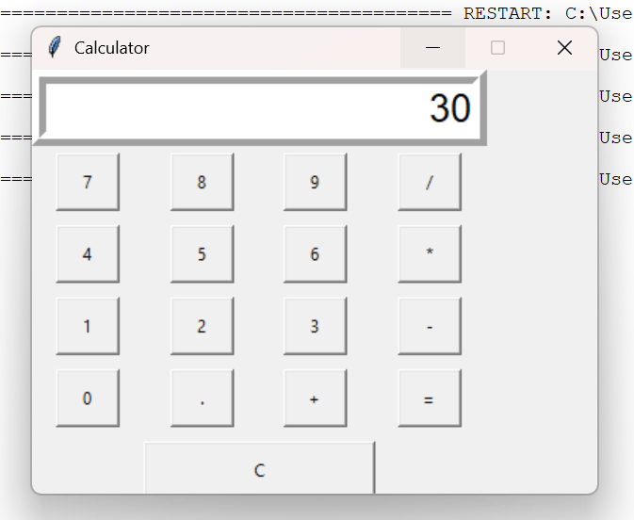
3.Design a GUI for student registration for a course and store these details in a database. Use Tkinter for UI, SQLite/MySQL for database storage.
CODE: -
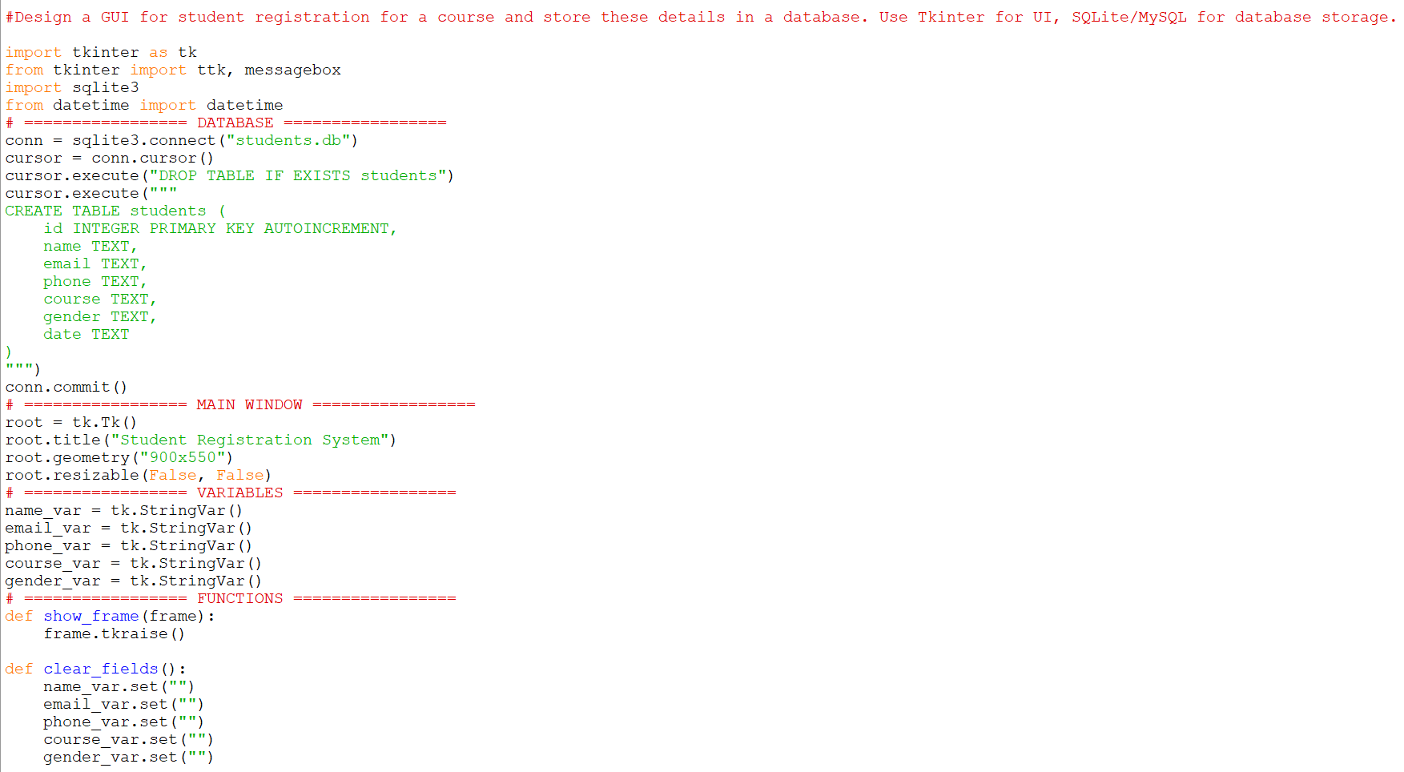
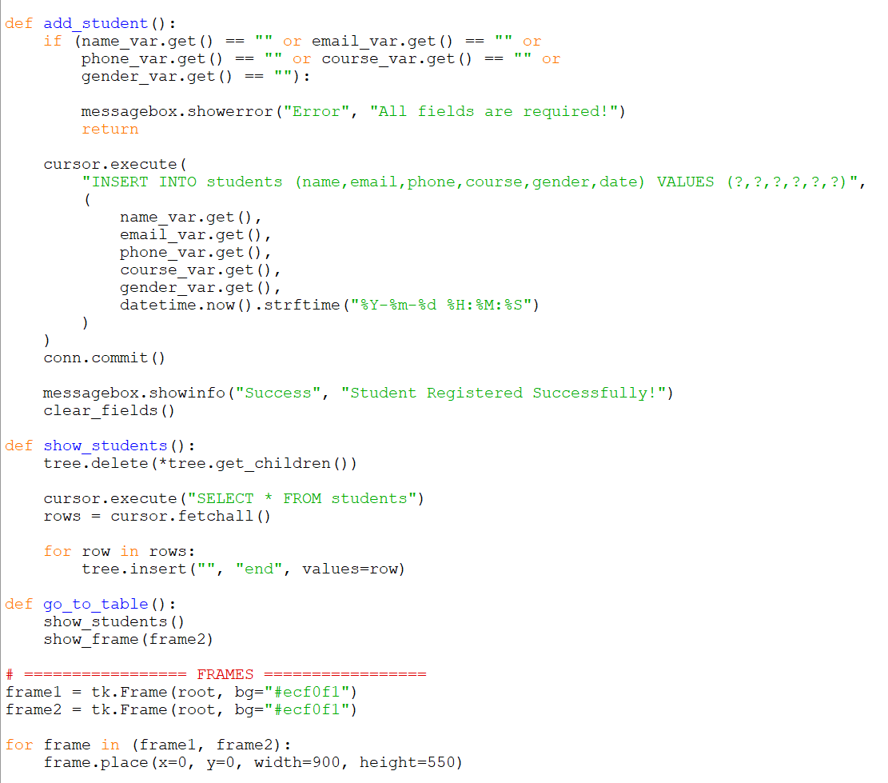
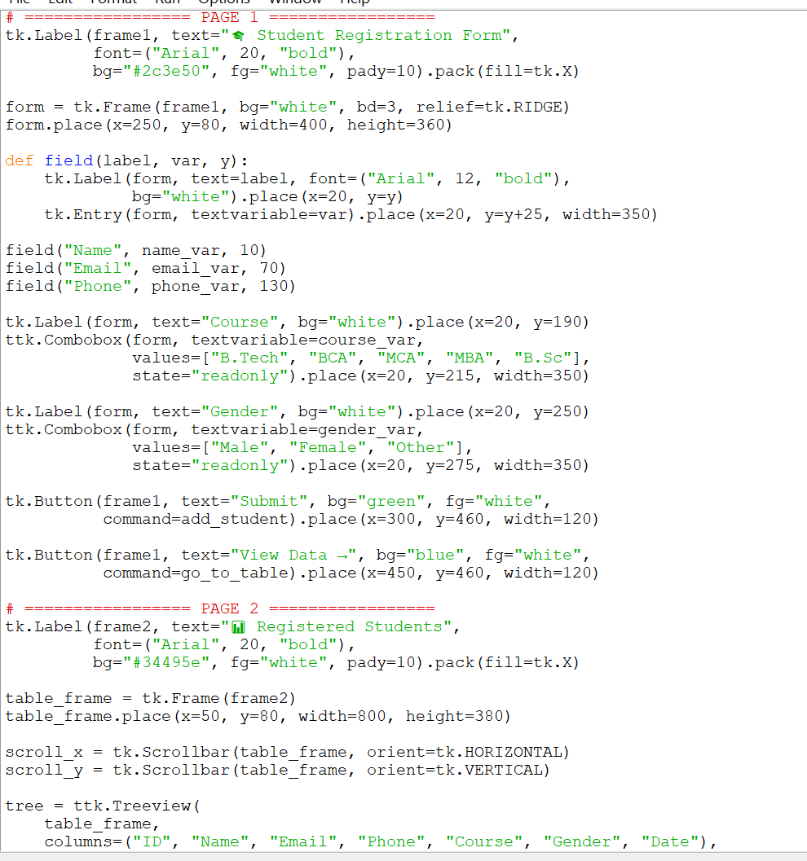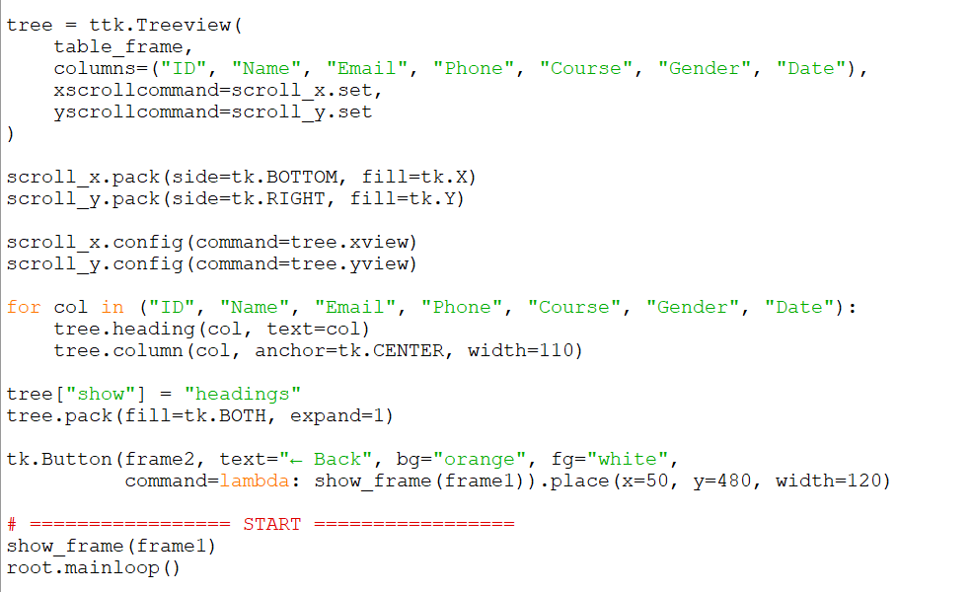

RESULT: -
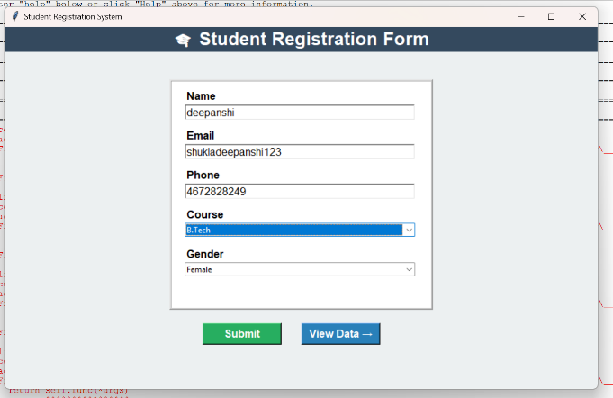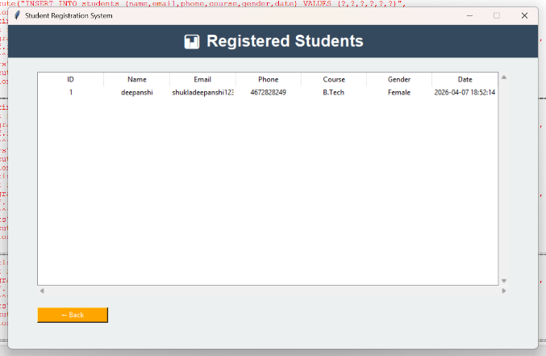
4. Create a GUI based task manager where users can add, edit and remove tasks. Use Tkinter (buttons, listbox), SQLite/MySQL (task storage).
CODE: -
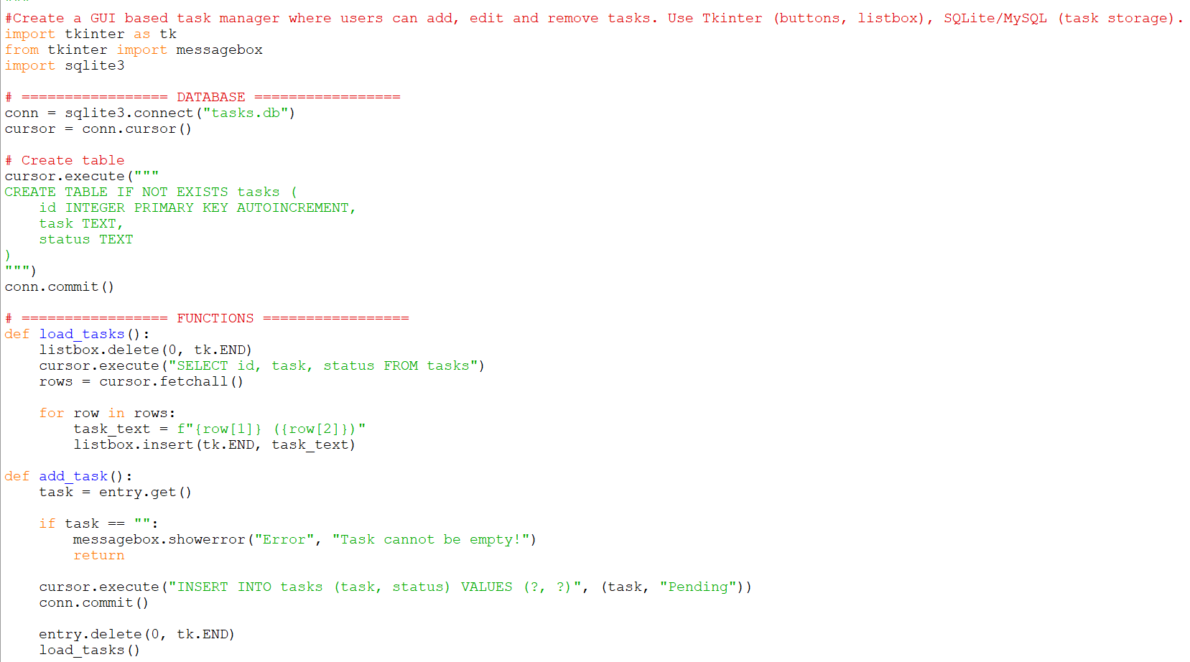
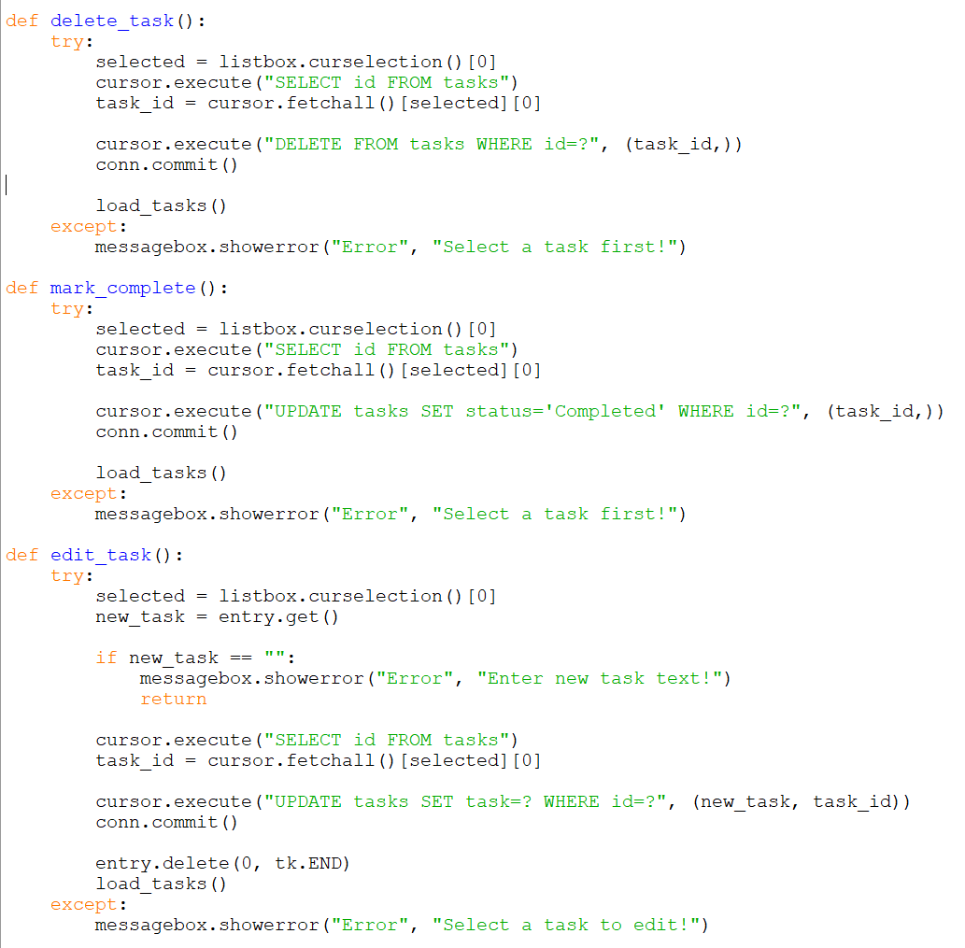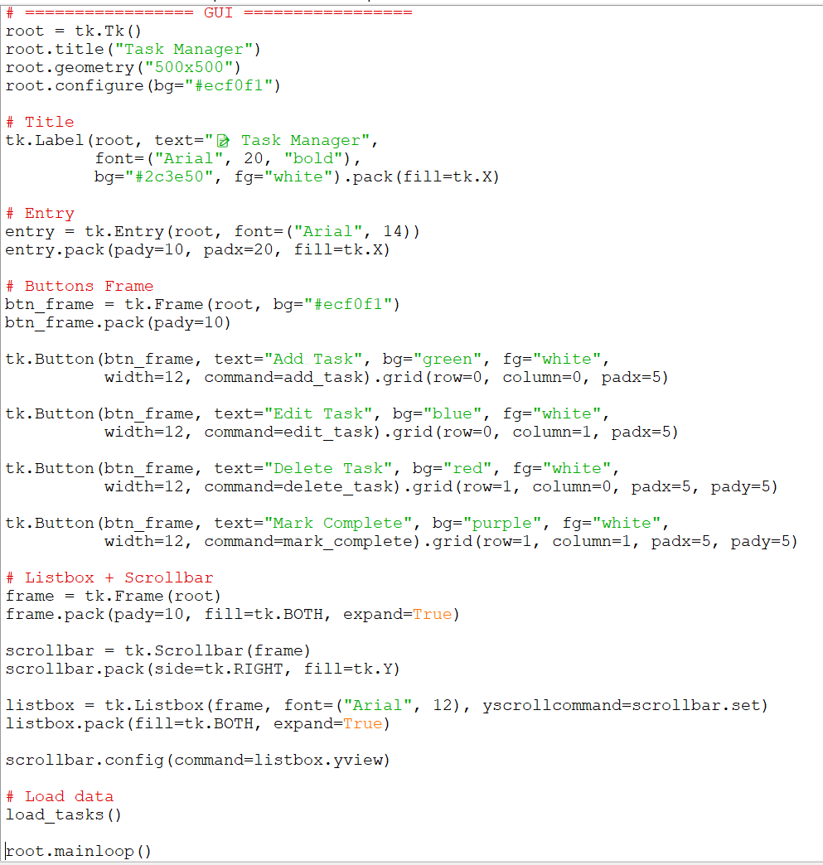

RESULT: -
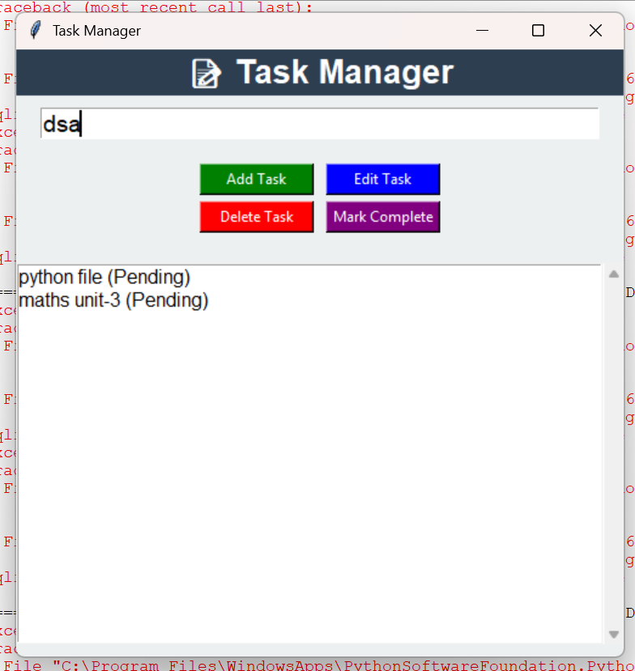
5. Design a login and signup authentication system.
CODE: -
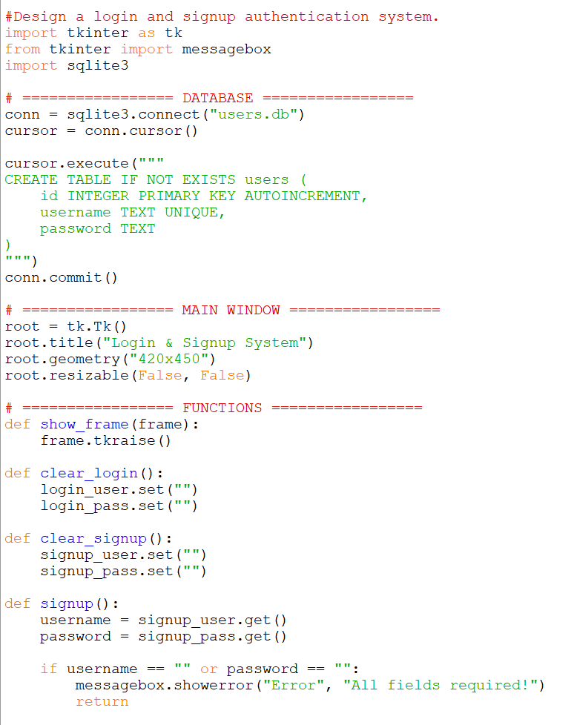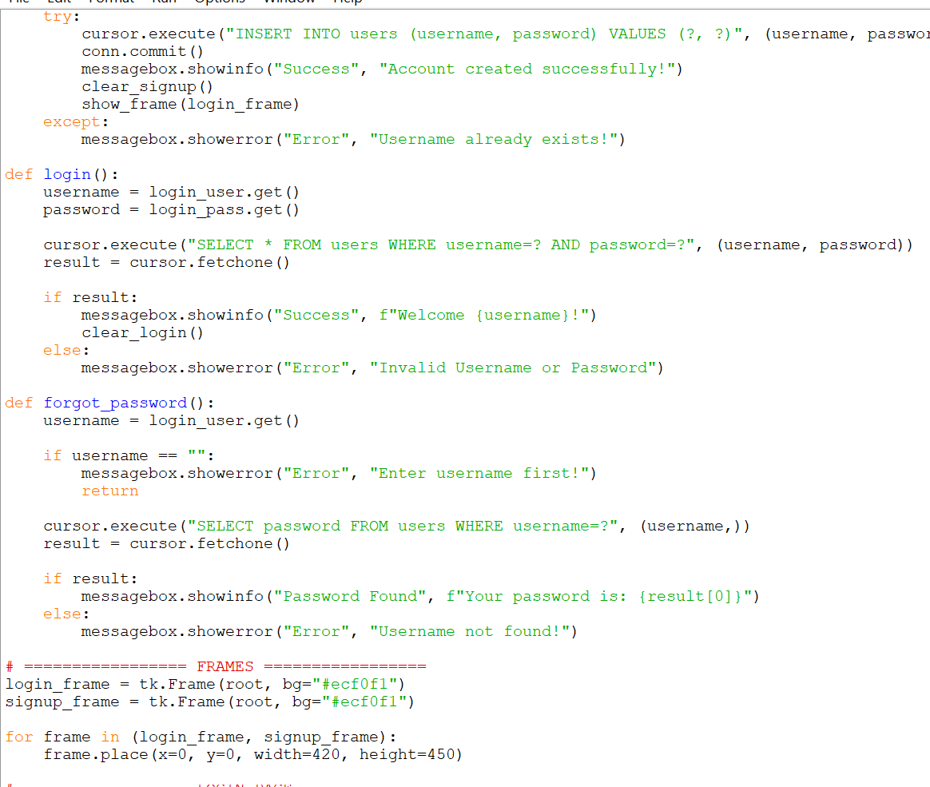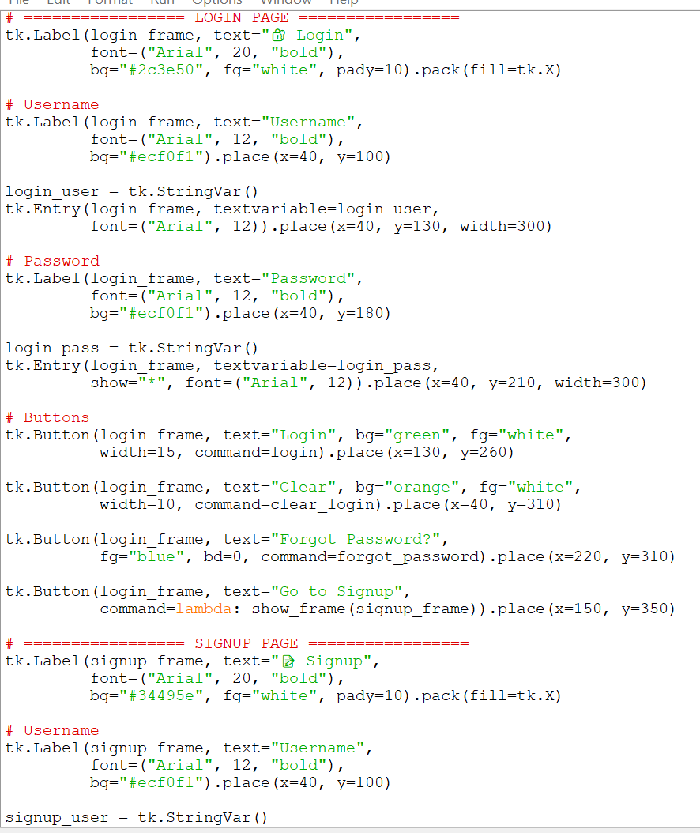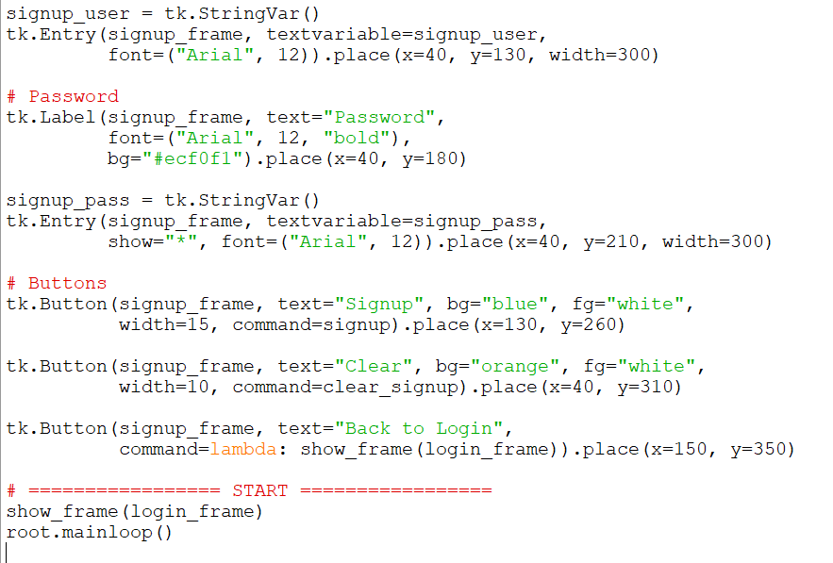

RESULT: -
